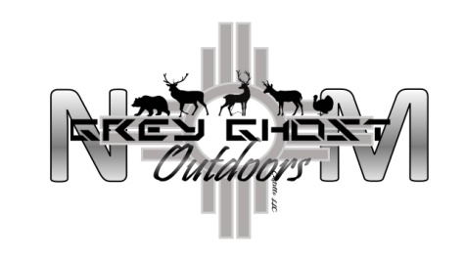

313 S 9th Ave
575-707-1647
575-707-0197
Raton, New Mexico 87740

General Information
Please fill out the necessary forms (available online) and return them as soon as possible.

We must receive these forms in order to complete the booking process of your hunt.
​
Hunters Checklist for New Mexico Guided Hunt
This checklist is an important resource for planning and organizing your hunt. It is intended as suggestions; you may add to the list to personalize your plans.
- Hunting License
- Ammunition, or Arrows
- Binoculars, Spotting Scope
- Boots for Cold, or Wet Weather and One Light Weight Pair for Hot Weather
- Gloves
- Jackets, Heavy and Light Weight (layers of clothing that can be pulled off and put on are best for the ever changing NM weather)
- Long Underwear
- Rain Gear
- Camera/Film
- Medication (if needed)
- Sunscreen
- Camouflage Clothing
- Personal Items
- Day Pack
- Water bottle
- Large Coolers (for meat, hides and capes)

Here are 10 tips for prospective hunters at Grey Ghost Outdoors NM, LLC.
- Our hunts will take place over ever changing terrain consisting of flat prairies to rocky ledges. Please be prepared for long hikes. Correct boots, clothing, lightweight gear packing, and the ability to haul your game from location to vehicle is important.
- Know your health abilities. Altitude sickness, fatigue and dehydration can be common health risks in the arid and dry climate of the high deserts of New Mexico. Altitude will range from 6,000 to 8,000 above see level, over a mile high!
- It’s ok to know your limitations. Unrealistic expectations can lead to unhappy results.
- Please follow our “guidance.” While we will make every effort to get you the kill, we also must look out for the safety of everyone involved and the preservation of the land.
- Know your weapon and all its accessories!
- Learn to shoot in different positions, standing, kneeling or laying down.
- Practice shooting long distances. There are lots of times up here that you need to shoot farther than 100 yards.
- AMMUNITION- bring the right size bullet and enough backups.Should you unfortunately not take the animal down on the first shot, a bullet big enough to leave a good blood trail helps. If you have any question on your choice of weapon or ammunition, we can help.
If you have any questions, feel free to contact us!

